Chapter 4, Problem 51.

Given the circuit in Fig. 4.117, obtain the Norton equivalent as viewed from terminals
- a-b and (b) c-d.

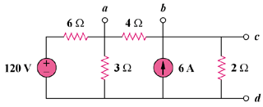

Figure 4.117
For Prob. 4.51.

